Practice 1 Semester Two Examination, 2016

Question/Answer Booklet

If required by your examination administrator, please place your student identification label in this box
SPECIALIST
UNITS 3 AND 4

Section One:

Calculator-free

Student Number: In figures

In words

Your name

Time allowed for this section
Reading time before commencing work: five minutes
Working time for section: fifty minutes

Materials required/recommended for this section
To be provided by the supervisor
This Question/Answer Booklet
Formula Sheet

To be provided by the candidate
Standard items: pens (blue/black preferred), pencils (including coloured), sharpener, correction fluid/tape, eraser, ruler, highlighters

Special items: nil

Important note to candidates
No other items may be taken into the examination room. It is your responsibility to ensure that you do not have any unauthorised notes or other items of a non-personal nature in the examination room. If you have any unauthorised material with you, hand it to the supervisor before reading any further.

Structure of this paper

Section | Number of questions available | Number of questions to be answered | Working  time (minutes) | Marks available | Percentage of exam
Section One:  Calculator-free | 7 | 7 | 50 | 52 | 35
Section Two:  Calculator-assumed | 12 | 12 | 100 | 101 | 65
 |  |  | Total | 153 | 100

1. [7 marks]

(a) Solve 1 + ⎪x − 2⎪ = 0. [1]

(b) Solve 1 + ⎪x − 2⎪ ≤ x + 1 . Show clearly how you obtained your answer. [3]

(c) Use an algebraic method to solve 1 + ⎪x − 2⎪ = x − 1 .
[3]

2. [12 marks]

Draw slope fields for the following differential equations

- 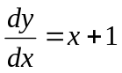
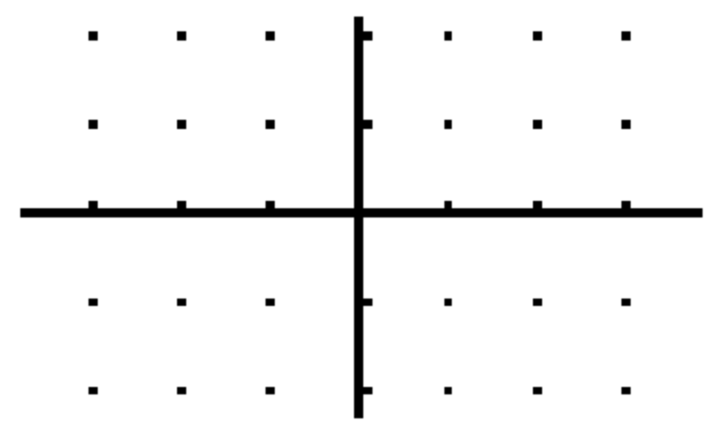

(b) 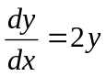

(c) 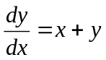

- 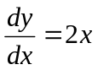

- 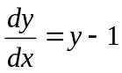

- 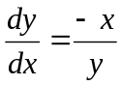

3. [5 marks]

Given that u = a + bi , v = b + ai where a and b are real integers,
find all possible values of a and b if u × v = 13i .
Show clearly how you obtained your answer.

4. [6 marks]

A complex number z = 1 + cis , −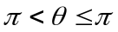.

(a) Determine Re(z) and Im(z), in terms of . [2]

(b) Hence, if = , find exact values for |z| and arg(z). [4]

5. [5 marks]

A curve is defined implicitly with the equation, y – x + 3e^{−y} = 1

Find the equation of the tangent to this curve at the point, (2, 0).

6. [8 marks]

Consider the rational function, f (x) = 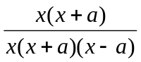 where a > 1.

(a) Find the equation of the horizontal asymptote(s) of f (x). [1]

(b) Find all values of x for which f (x) is not defined. [2]

(c) Find the limit of f (x) as x approaches 0. [2]

(d) For a = 2, sketch the graph of f (x). Indicate all essential features of this graph. [3]

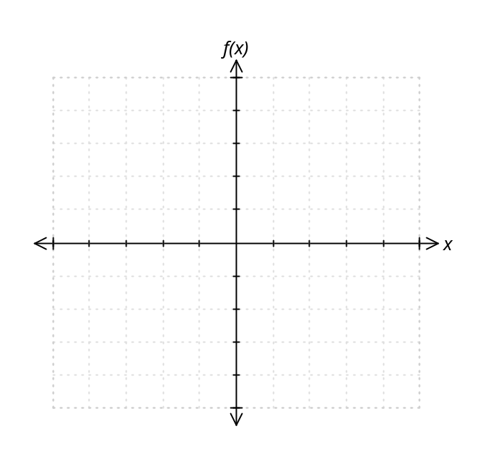
7. [0 marks]

Evaluate the following integrals, showing sufficient working to justify your answers.

(a) 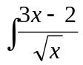 dx [2]

(b) 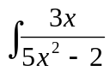 dx [2]

(c) Use the substitution x = tan to show that 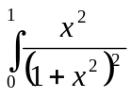 dx = 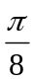 –  [5]

Practice 1 Semester Two Examination, 2016

Question/Answer Booklet

If required by your examination administrator, please place your student identification label in this box
SPECIALIST
UNITS 3 AND 4

Section Two:

Calculator-assumed

Student Number: In figures

In words

Your name

Time allowed for this section
Reading time before commencing work: ten minutes
Working time for section: one hundred minutes

Materials required/recommended for this section
To be provided by the supervisor
This Question/Answer Booklet
Formula Sheet (retained from Section One)

To be provided by the candidate
Standard items: pens (blue/black preferred), pencils (including coloured), sharpener, correction fluid/tape, eraser, ruler, highlighters

Special items: drawing instruments, templates, notes on two unfolded sheets of A4 paper, and up to three calculators approved for use in the WACE examinations

Important note to candidates
No other items may be taken into the examination room. It is your responsibility to ensure that you do not have any unauthorised notes or other items of a non-personal nature in the examination room. If you have any unauthorised material with you, hand it to the supervisor before reading any further.

Structure of this paper

Section | Number of questions available | Number of questions to be answered | Working  time (minutes) | Marks available | Percentage of exam
Section One:  Calculator-free | 7 | 7 | 50 | 52 | 35
Section Two:  Calculator-assumed | 12 | 12 | 100 | 101 | 65
 |  |  | Total | 153 | 100

Instructions to candidates

1. The rules for the conduct of examinations are detailed in the school handbook. Sitting this examination implies that you agree to abide by these rules.

2. Write your answers in this Question/Answer Booklet.

3. You must be careful to confine your response to the specific question asked and to follow any instructions that are specified to a particular question.

4. Spare pages are included at the end of this booklet. They can be used for planning your responses and/or as additional space if required to continue an answer.
- Planning: If you use the spare pages for planning, indicate this clearly at the top of the page.
- Continuing an answer: If you need to use the space to continue an answer, indicate in the original answer space where the answer is continued, i.e. give the page number. Fill in the number of the question that you are continuing to answer at the top of the page.

5. Show all your working clearly. Your working should be in sufficient detail to allow your answers to be checked readily and for marks to be awarded for reasoning. Incorrect answers given without supporting reasoning cannot be allocated any marks. For any question or part question worth more than two marks, valid working or justification is required to receive full marks. If you repeat any question, ensure that you cancel the answer you do not wish to have marked.

6. It is recommended that you do not use pencil, except in diagrams.

7. The Formula Sheet is not to be handed in with your Question/Booklet.

8. [14 marks]

If z = −1 − i
(a) Simplify (5 cis 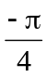) × z and give your answer in exact polar form. [2]

(b) Simplify 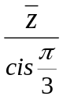 where is the conjugate of z and give your answer in
exact polar form. [2]

(c) Use De Moivre’s Theorem to find all complex numbers, w,
where w³ = ( –4 – 4i ).
Show clearly how you obtained your answers and give your answers in polar form. [4]

(d) On the diagram below, sketch the locus of the point z
where z + = 6. [2]
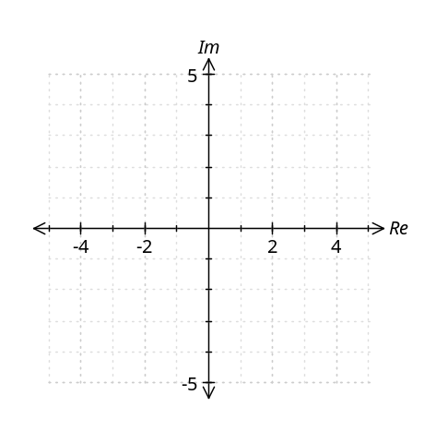
(e) On the diagram below, sketch the locus of the point z
where ⎪z⎪ + ⎪⎪ = 8. [2]
(f) On the diagram below, sketch the locus of the point z where
arg (z) − arg () = 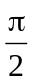 [2]

9. [6 marks]


Becky is riding her motorcycle along a straight country road. Three signposts A, B and C are evenly spaced along the side of this road
such that AB = BC = 90 metres. It takes her 6 seconds to travel
between A and B and 4 seconds to travel between B and C.

If she is travelling with constant acceleration, use calculus techniques to find:

(a) the constant acceleration. [4]

(b) the speed at which she is travelling as she passes C. [2]

10. [9 marks]

(a) The equation of motion of a body is given by 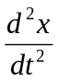 + 16x = 0, where x is the distance
of the body (in cm) to a fixed point O and t is time in seconds. It is known that the
body starts moving from O with a velocity of −1 cm s⁻¹.
Show clearly that x = Asin (ωt + α) giving the values of A, ω (where ω > 0) and α.
[5]

(b) The equation of motion of another body is given by x = 2 cos (0.5 t ).
Find the average speed of the body in the first ten seconds.
Show clearly how you obtained your answer. [4]

11. [7 marks]

(a) Show that the line L whose vector equation is 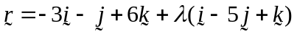 is parallel to the plane 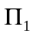 whose vector equation is 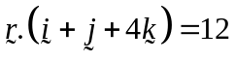. [2]

(b) Find the equation of the plane 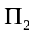 that contains the line L and is parallel to . [2]

(c) Find the distance of and from the origin and hence, or otherwise, determine the distance between the planes. [3]

12. [6 marks]


The temperature, in degrees Celsius, of an object removed from an oven,
slowly decreases to room temperature. After m minutes out of the oven, the temperature, T, of the object is given by,
T = Ae^{km} + 25, where A and k are both constant.

(a) Show how to obtain the differential equation, 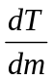 = k(T – 25) [2]

(b) If T = 86C after 9 minutes, and T = 76C after 15 minutes,
find values for A, to the nearest degree, and k, correct to 2 decimal places. [4]

13. [10 marks]

The graph below shows the sketch of y = e^{−(x − 2)2}
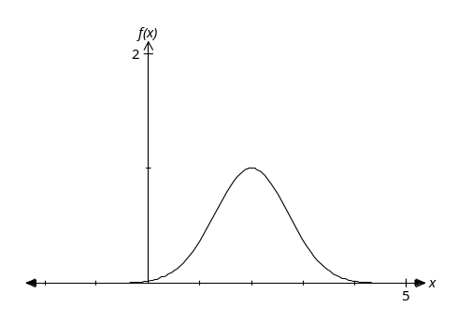
(a) Write an integral expression that will give the area of the region enclosed by
the curve, the x-axis, the y-axis and the line x = 2.
Find the approximate area of this region. [3]

(b) Find, correct to 4 decimal places, the area of the region between the curve
and the x-axis which lies to the right of the line x = 2.
Show clearly the expressions you used to evaluate this area. [4]

(c) The region described in part (a) is rotated through 2π radians about the x-axis.
Write an integral expression that will give the volume of the solid formed.
Find the volume of this solid. [3]

14. [5 marks]

The variables P and x are related by the formula, P = 2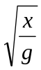 , where g is a constant.
Use the incremental formula to show that a 1% increase in x will result in a
0.5% increase in P.

15. [9 marks]

The volume of a meteorite decreases once it enters the Earth’s atmosphere.
Its distance from the Earth’s surface, s kilometres, is related to its volume,
V cubic metres, via the equation, V = 6 + 50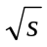

(a) Find 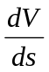 when the meteorite is 36 km above the Earth’s surface. [2]

The meteorite is spherical in shape, and its approximate distance, s, from the Earth’s surface, t minutes after entering the Earth’s atmosphere is given by
s = 100 – 0.5t .

(b) Find the rate of change of the volume of the meteorite with respect to time
when s = 36. [4]

(c) Find the speed at which the meteorite hits the Earth’s surface. [3]

16. [12 marks]

Consider the three functions f (x) = 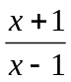, g (x) = 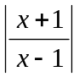, h (x) = 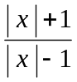 .

Write down the domain and range for each of the following,

 | Domain | Range
f (x)

f ⁻¹(x)

g (x)

h (x)

f ( f (x))

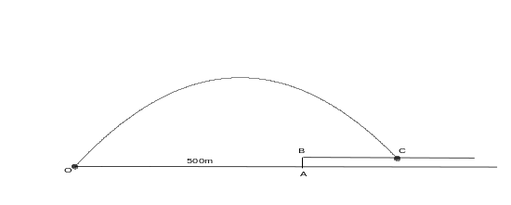17. [10 marks]

For a fireworks display, a small rocket is fired
from ground level, at 100 metres per second, to
land at point C somewhere on a horizontal platform
5 metres above the ground. The point O, from
which the rocket is fired, is 500 metres from the
platform. The rocket is subjected to the acceleration vector, a = -9.8j, and is initially fired
at 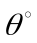 to the horizontal.

(a) If = 30º, show that the position vector of the rocket after t seconds is given by
r = 50√3 i + (50t − 4.9t² ) j [3]
(b) Hence, find the length of time the rocket is in the air. [2]

17. (c) The technician is asked to adjust the angle at which the rocket is fired in order
to land 200 metres along the platform. Find if BC = 200. [5]

18. [6 marks]
Solve 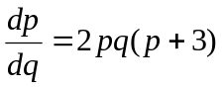 if 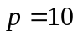, when 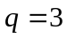

19.

[7 marks]

Given 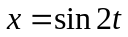 and 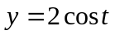
(a) Show that the parametric equations can be used to form the Cartesian equation
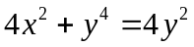. [3]

(b) Find the equation of the tangent to the curve when 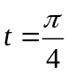. [4]

END OF EXAM
This page intentionally left blank.

This page intentionally left blank.

